

**AMERICAN INTERNATIONAL UNIVERSITY–BANGLADESH (AIUB)**

**DEPARTMENT OF INTRODUCTION TO DATABASE**

**Summer 2020-2021**

**Section: H, Group: [6]**

**Project Name**

**Air Accessing Management System (Case Study & ER Diagram)**

**Submitted by:**

|  |  |
| --- | --- |
| NAME | ID |
| **Ahmed,Tousif** | **20-43627-2** |
| **Rahat,Md.Saimun Islam** | **20-43632-2** |
| **Abir,Ittishaf Bashar** | **20-43634-2** |
| **Siddqua,Shinzon** | **20-43671-2** |
| **Adikta,Ridita Zaman** | **20-43679-2** |

**Date of Submission: 16 August,2021**

**Submitted To:**

**Kawser Irom Rushee**

**Case Study**

In an air accessing management system there are several sectors where we can see main airport sector, employed workers, airplane owner, airlines, flight schedule and so many other sectors. Airport location, city, country, airport name, code number; these things are stored in the airport sector. Available planes and flights are recorded in airplane and flight sector. Airplane registration number, types and specific seats are recorded in this sector. There are several owners and airplanes in an airport. Airlines location, code number, owner’s e-mail, phone number and name are also recorded in the files. All these works are done by specific workers in the specific sectors. Several employees are selected for each sectors. A worker’s name, hiring date, ID, salary everything are noted. Flights get booked by booking officers. Departure date, flight number, arrival times, destination all get confirmed by the booking officer. One flight get booked by many passengers. The booking officers provides them the tickets, where passenger name, price, order number and flight number are mentioned. One ticket for one passenger. Passenger name, date of birth, phone number, order number, address and gender get recorded in the booking sector. One passenger can book many tickets.

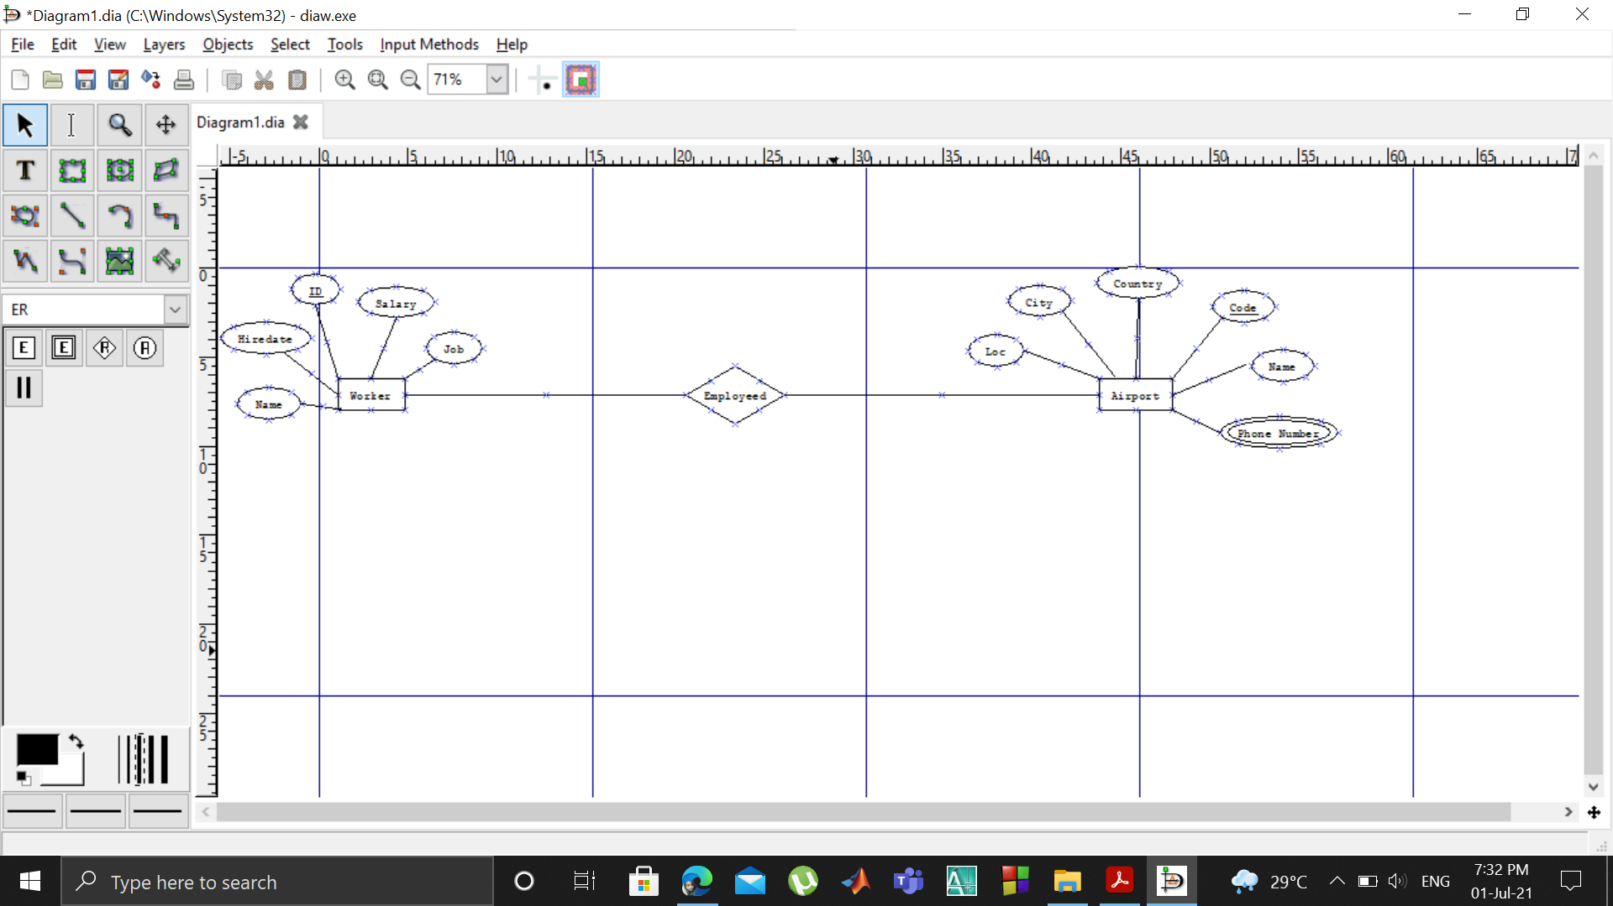

**(Starting)**

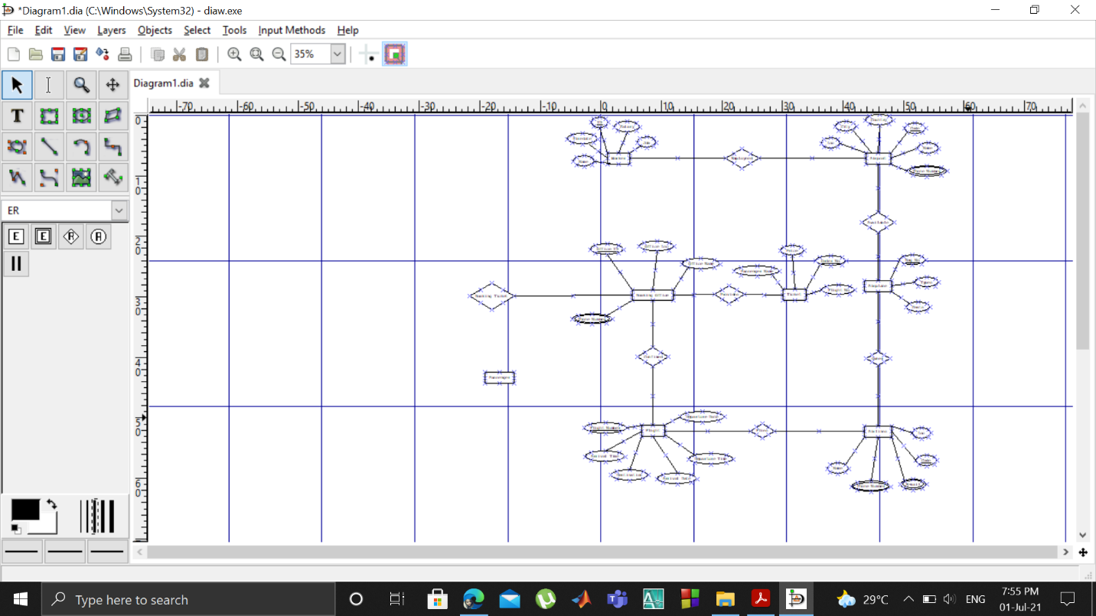

**(Ending)**

**ER Diagram:**

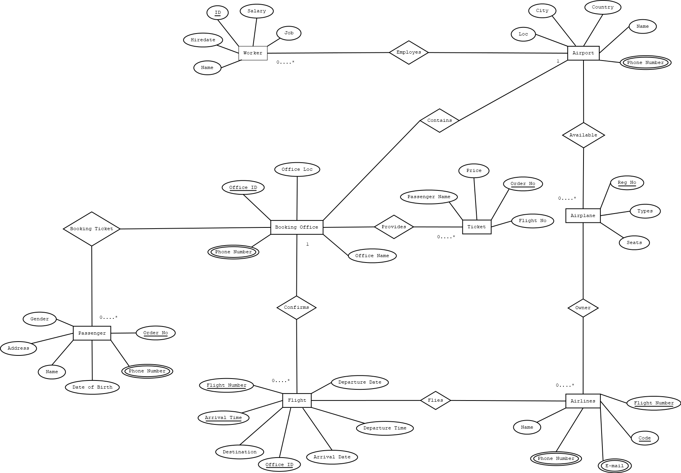

**Normalization :**

employeed

Worker--------------------------------- --------------------------Airport

**UNF :**

(**ID**,Name,Job,Hiredate,Salary,Code,Name,Country,City,Loc,Phone)

**1NF :**

Phone Has Multi Value Attribute

**2NF :**

1. **ID**,Name,Job,Hiredate,Salary

2. Code,Name,Country,City,Loc,Phone

**3NF :**

1. **ID**,Name,Job,Hiredate,Salary

2. Code,Name,Country,City,Loc,Phone

**Table :**

Worker (**ID**,Name,Job,Hiredate,Salary,Code)

Airport (Code,Name,Country,City,Loc,Phone)

Airport---------------------------------- --------------------------Airplanes

available

**UNF :** Code,Name,Country,City,Loc,Phone,Reg No

**1NF :**

Phone Has Multi Value Attribute

**2NF :**

1. Code,Name,Country,City,Loc,Phone
2. Reg No,Types,Seats

**Table :**

Airport (Code,Name,Country,City,Loc,Phone,Reg no)

Airplane (Reg No,Types,Seats)

Airplanes------------------------------- --------------------------Airlines

Owner

**UNF :** owner (Code,Name,Types,Seats,Loc,Phone,Reg No,email,)

**1NF :**

Phone,Email Has Multi Value Attribute

**2NF :**

1. Reg No,types,seats
2. Code,Name,Phone,Loc,Email

**Table:**

Airplane (Reg No,Types,Seats, code )

Airline (Code,Name,Phone,Loc,Email)

Airlines--------------------------------- --------------------------flight

Flies

**UNF :** Flies (Code,Name,Loc,Phone,Email,FlightNo,Arrival

Time,Destination,Arrival Date,Departure Time,Departure Date)

**1NF :**

Phone,Email Has Multi Value Attribute

**2NF :**

1. Code,Name,Phone,Loc,Email
2. Flight No,Arrival Time,Destination,Arrival Date,Departure Time,Departure Date

**Table:**

Airline (Code,Name,Phone,Loc,Email, Flight No )

Flight (FlightNo,Arrival Time,Destination,Arrival Date,Departure Time,Departure Date)

flight ---------------------------------- --------------------------Booking

confirm

**UNF:** (Flight no,Office ID,Office Name,Office Loc,Phone,Arrival

Time,Destination,Arrival Date,Departure Time,Departure Date)

**1NF :**

Phone Has Multi Value Attribute

**2NF :**

1. Flight No,Arrival Time,Destination,Arrival Date,Departure

Time,Departure Date

1. **Office ID**,Office Name,Office Loc,Phone)

**3NF:**

1. Flight No,Arrival Time,Destination,Arrival Date,Departure

Time,Departure Date

1. **Office ID**,Office Name,Office Loc,Phone)

**Table:**

Flight (FlightNo,Arrival Time,Destination,Arrival Date,Departure

Time,Departure Date, **Office ID** )

Booking Office (**Office ID**,Office Name,Office Loc,Phone)

Booking Office------------------------- --------------------------Ticket

Provides

**UNF :** Provides(Flight no,**Office ID**,Office Name,Office Loc,Phone,Order

No,Price)

**1NF :**

Phone Has Multi Value Attribute

**2NF :**

1. **Office ID**,Office Name,Office Loc,Phone
2. Ticket No,Price,Flight No

**3NF:**

1. **Office ID**,Office Name,Office Loc,Phone
2. Ticket No,Price,Flight No

**Table:**

Booking Office (**Office ID**,Office Name,Office Loc,Phone Ticket No )

Ticket (Ticket No,Price,Flight No)

Passanger -------------------------------------- ---------------------------------Booking Office

Books Ticket

**UNF** : Books Ticket (Order No,Name,Address,Gender,Phone,**Office ID**,Office

Name,Office Loc,Ofiice Phone, Ticket No)

**1NF :**

Phone Has Multi Value Attribute

**2NF :**

1. Order No,Name,Address,Gender,Phone
2. **Office ID**,Office Name,Office Loc,Ofiice Phone, Ticket No

3NF:

1. Order No,Name,Address,Gender,Phone
2. **Office ID**,Office Name,Office Loc,Ofiice Phone, Ticket No

**Table:**

Passanger (Order No,Name,Address, Gender,Phone, **Office ID** )

Booking Office (Office ID,Office Name,Office Loc,Ofiice Phone, Ticket

No)

After Normalization:

1. **ID**,Name,Job,Hiredate,Salary

2~~. Code,Name,Country,City,Loc,Phone~~

1.Code,Name,Country,City,Loc,Phone

2.~~Reg No,Types,Seats~~

1.Reg No,types,seats

2.~~Code,Name,Phone,Loc,Email~~

1.Code,Name,Phone,Loc,Email

2.~~Flight No,Arrival Time,Destination,Arrival Date,Departure Time,Departure Date~~

1.Flight No,Arrival Time,Destination,Arrival Date,Departure

Time,Departure Date

2**.~~Office ID~~**~~,Office Name,Office Loc,Phone)~~

1**.Office ID**,Office Name,Office Loc,Phone

2.Ticket No,Price,Flight No

1.Order No,Name,Address, Gender,Phone

**2.Office ID**,Office Name,Office Loc,Ofiice Phone, Ticket No

**Final Normalization:**

1. ID,Name,Job,Hiredate,Salary
2. Code,Name,Country,City,Loc,Phone
3. Reg No,types,seats
4. Code,Name,Phone,Loc,Email
5. Flight No,Arrival Time,Destination,Arrival Date,Departure

Time,Departure Date

1. Office ID,Office Name,Office Loc,Phone
2. Ticket No,Price,Flight No
3. Order No,Name,Address, Gender,Phone
4. Office ID,Office Name,Office Loc,Ofiice Phone, Ticket No

**Table Creation:**

1.Worker:

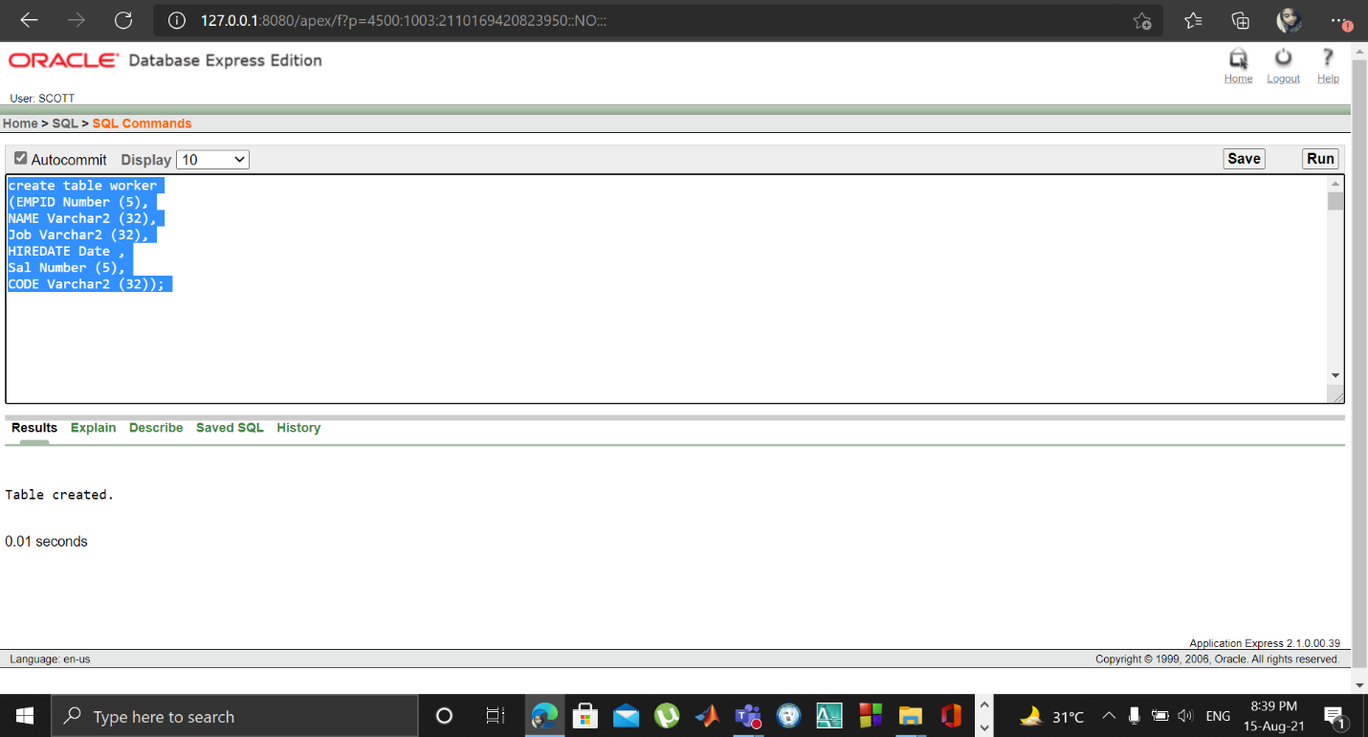

2.Airport:

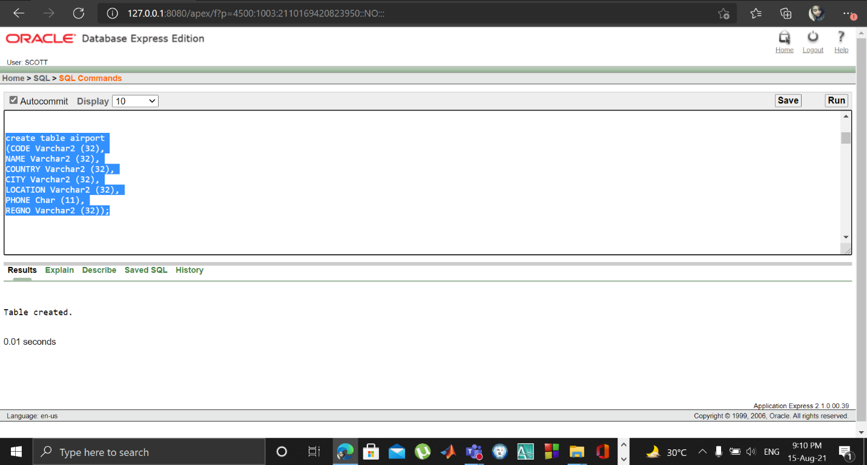

3.Airplane:

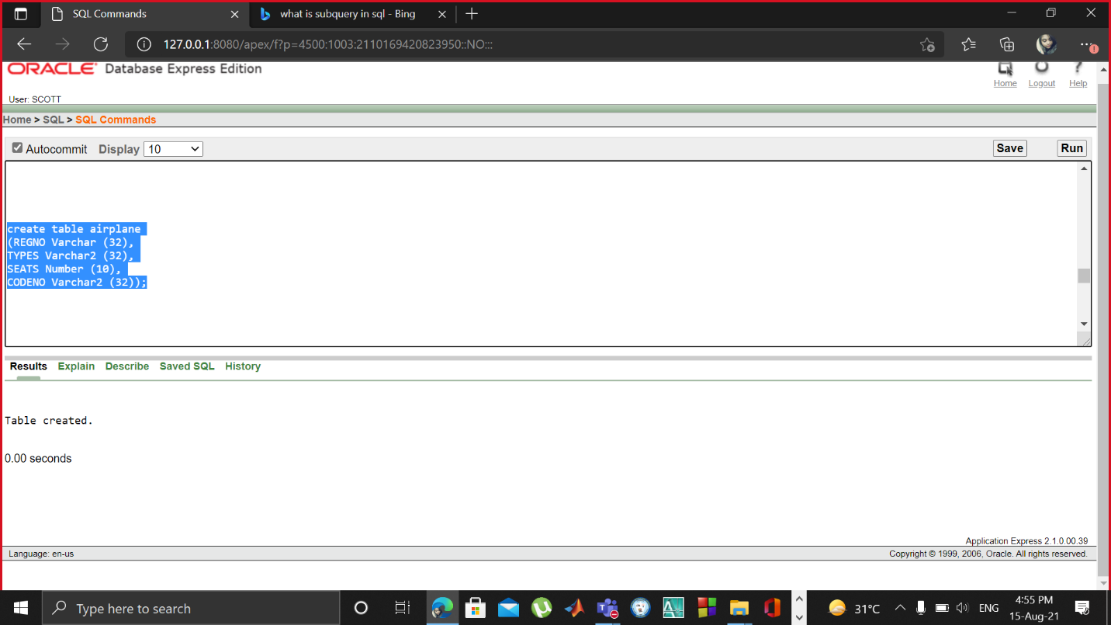

4.Airline:

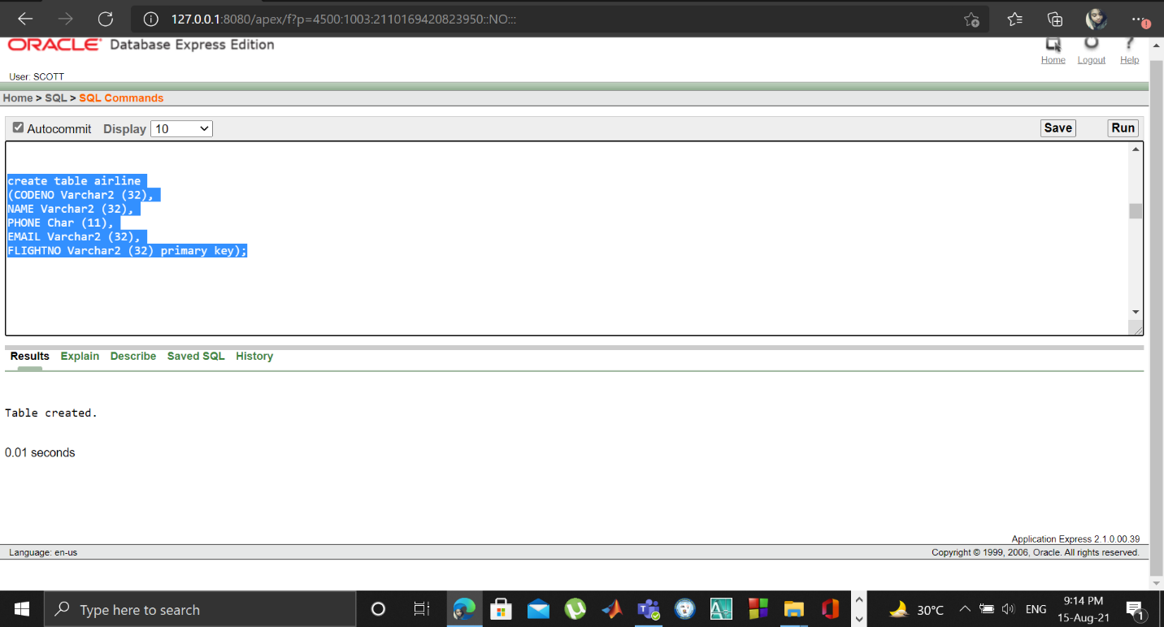

5.Flight:

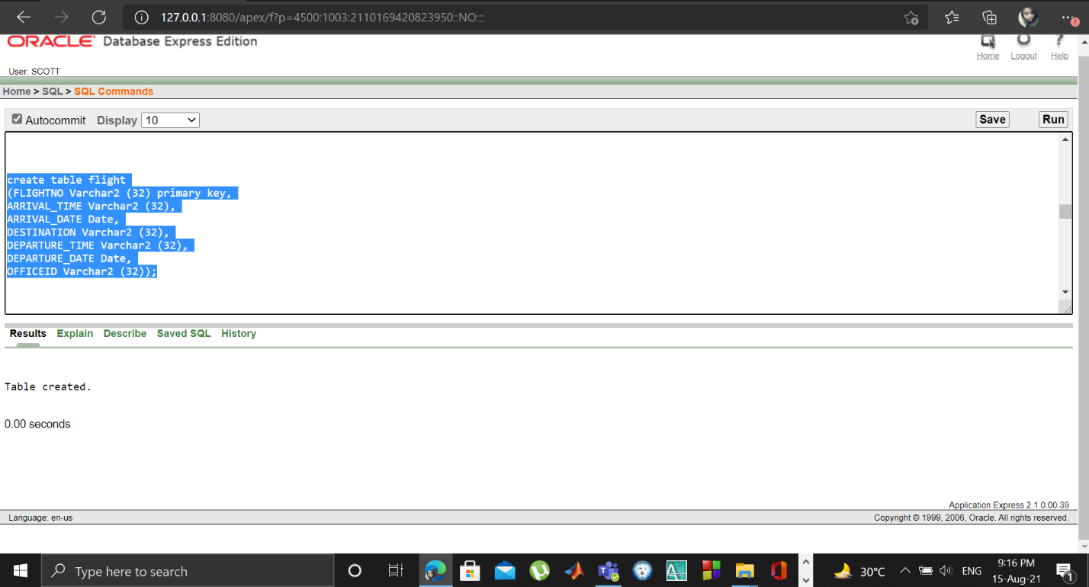

6.BookingOff:

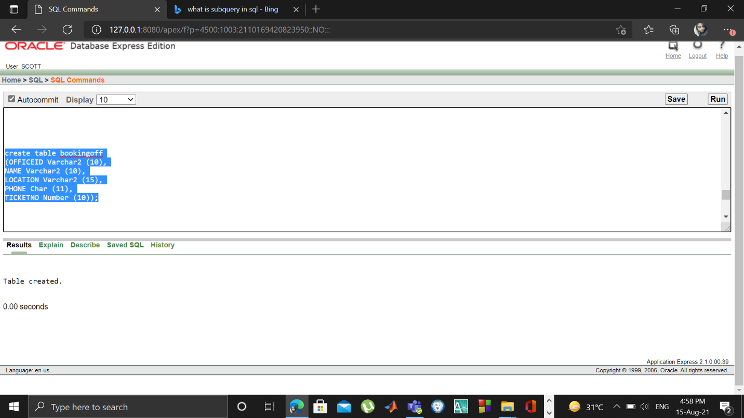

7.Ticket:

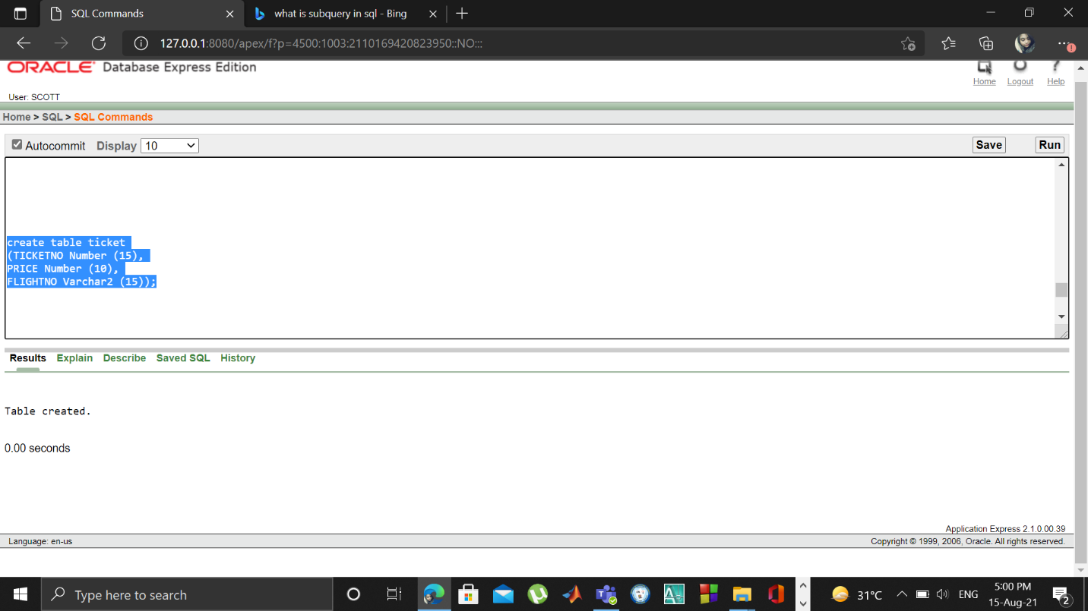

8.Passenger:

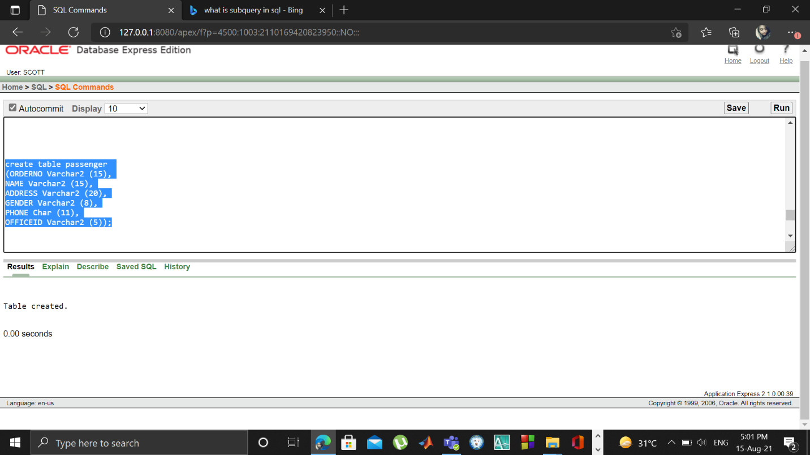

**Data Insertion:**

1.Worker:

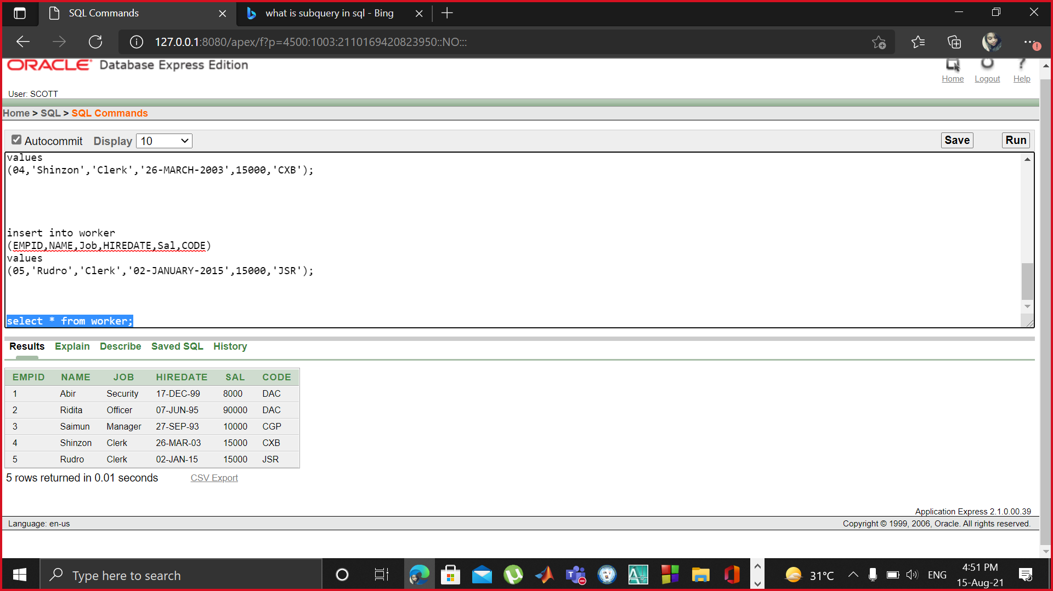

2.Airport:

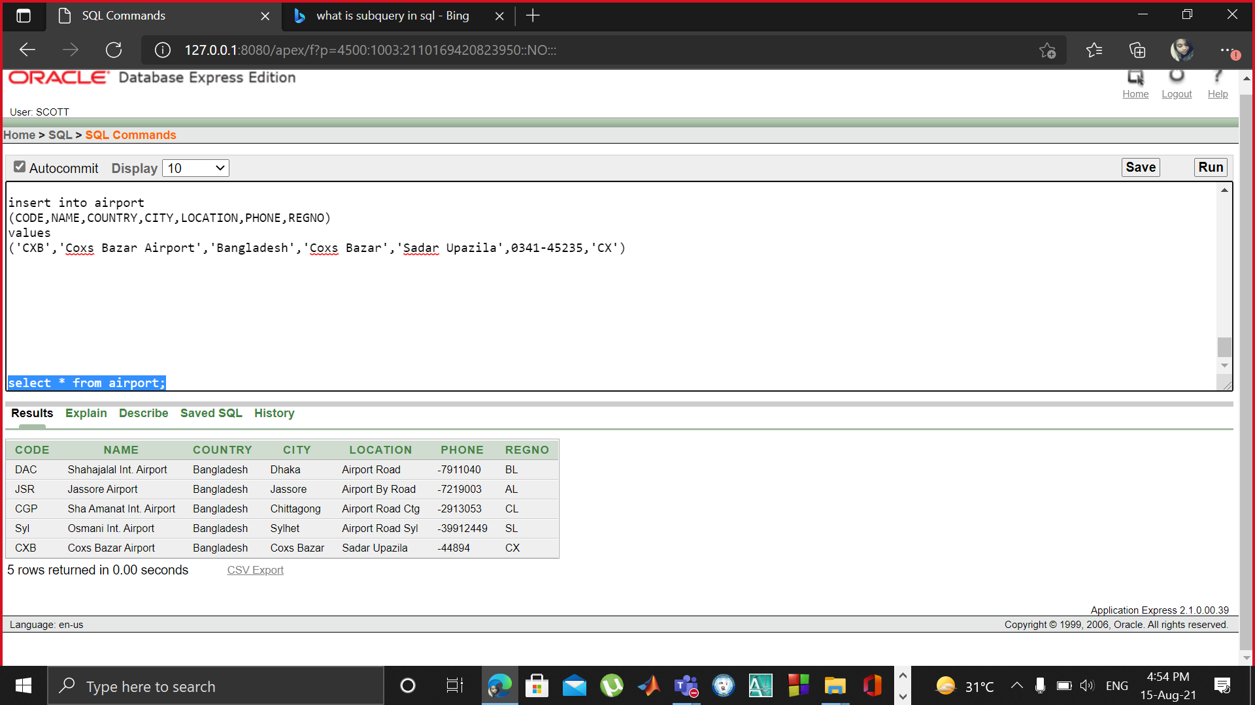

3.Airplane:

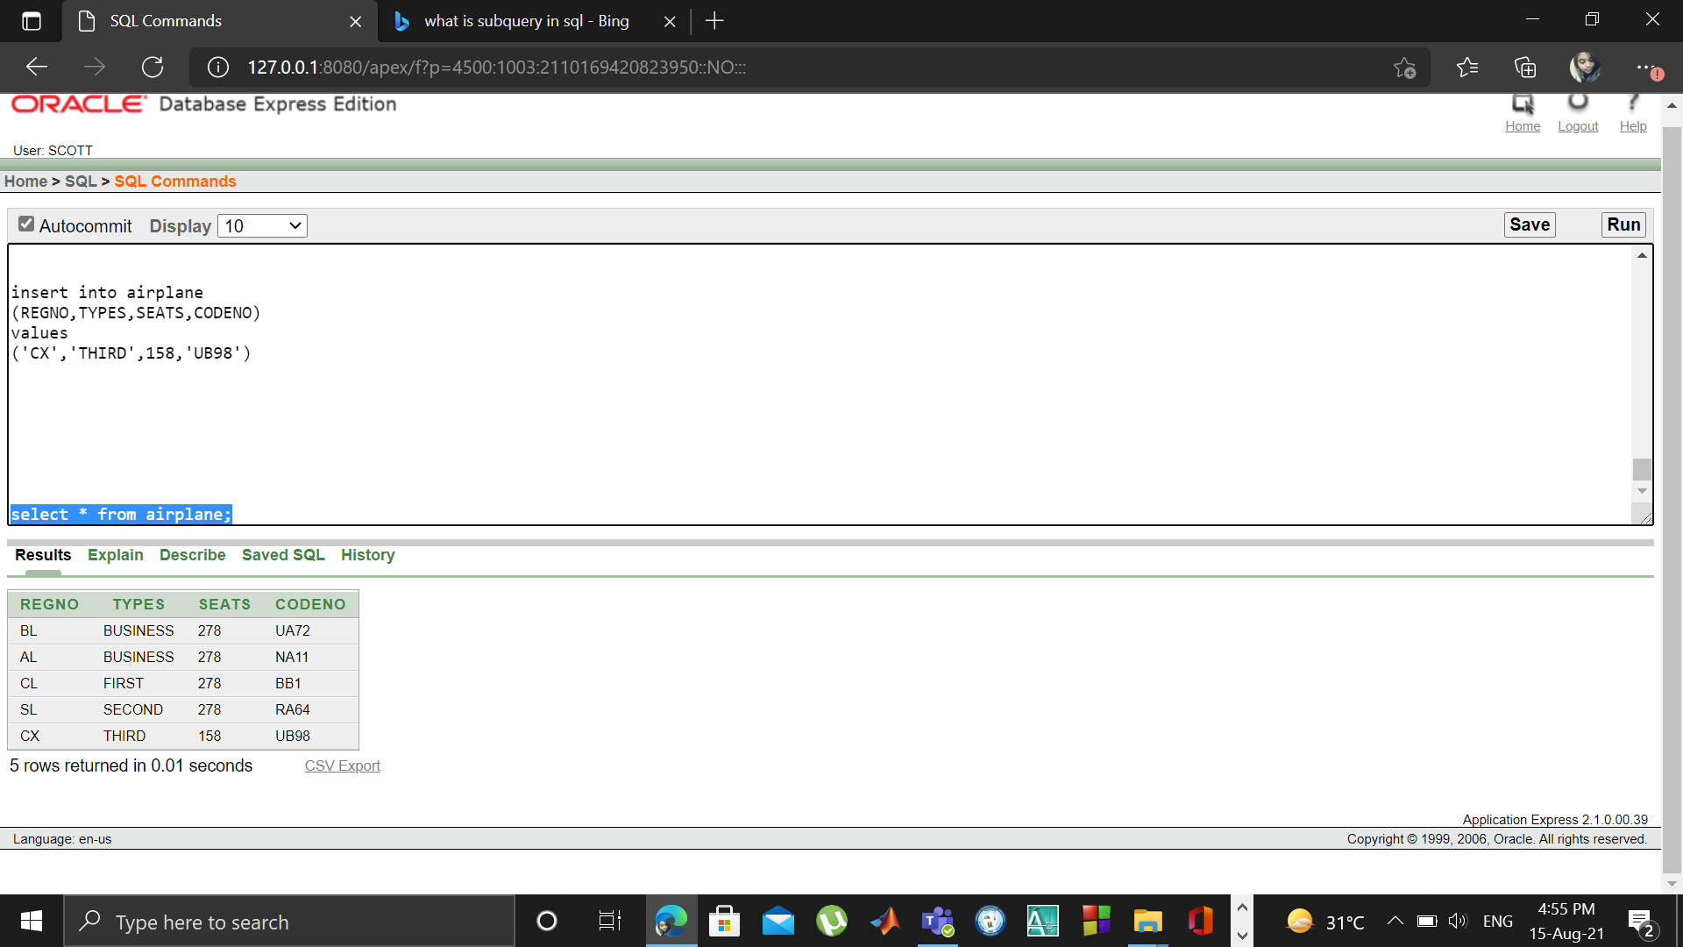

4.Airline:

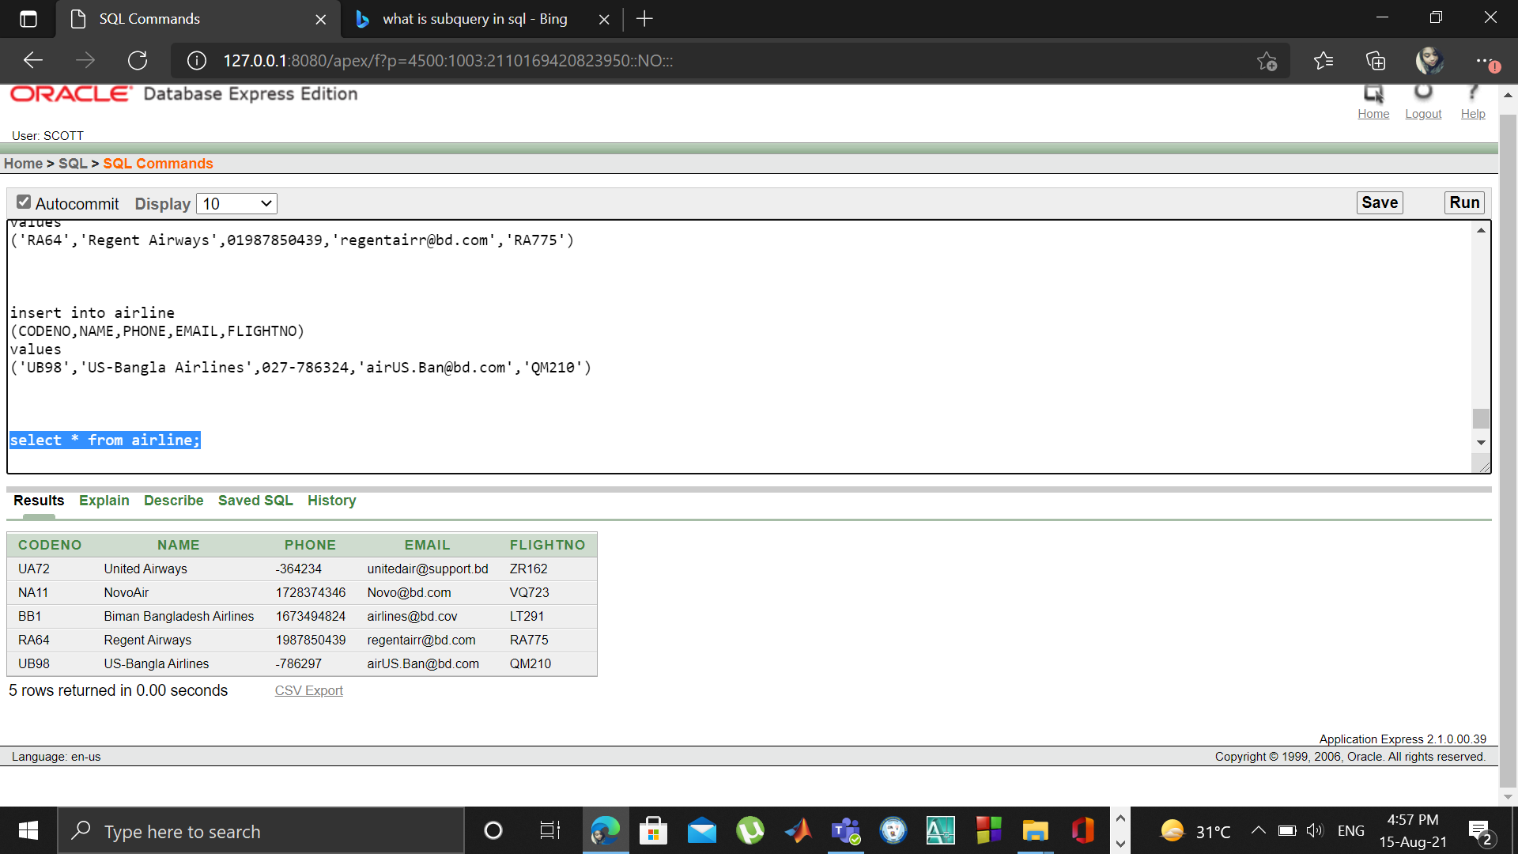

5.Flight:

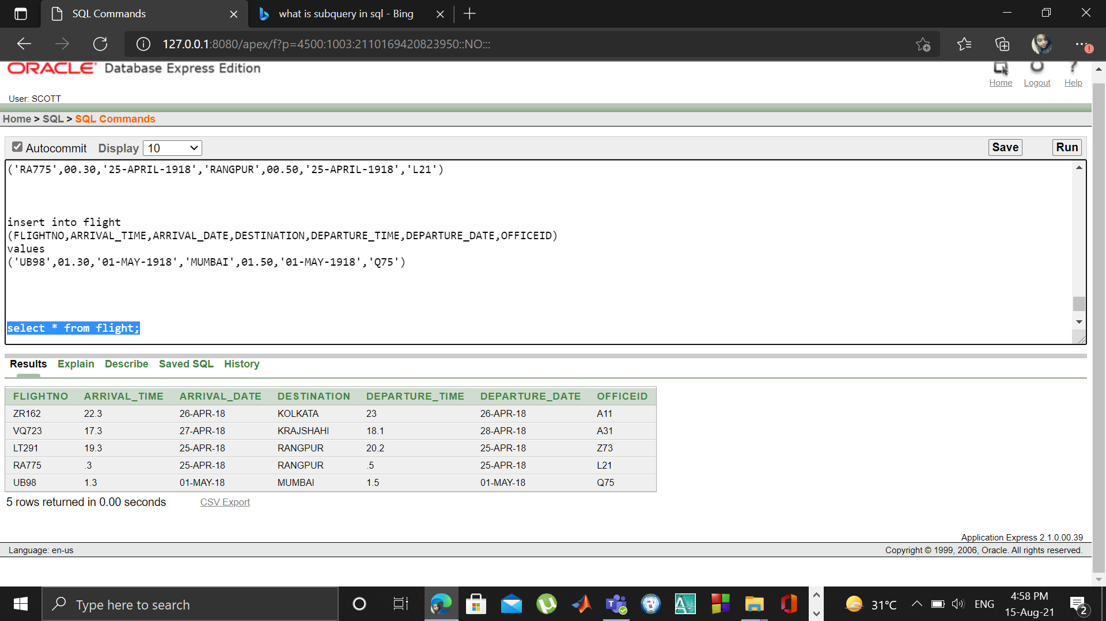

6.BookingOff:

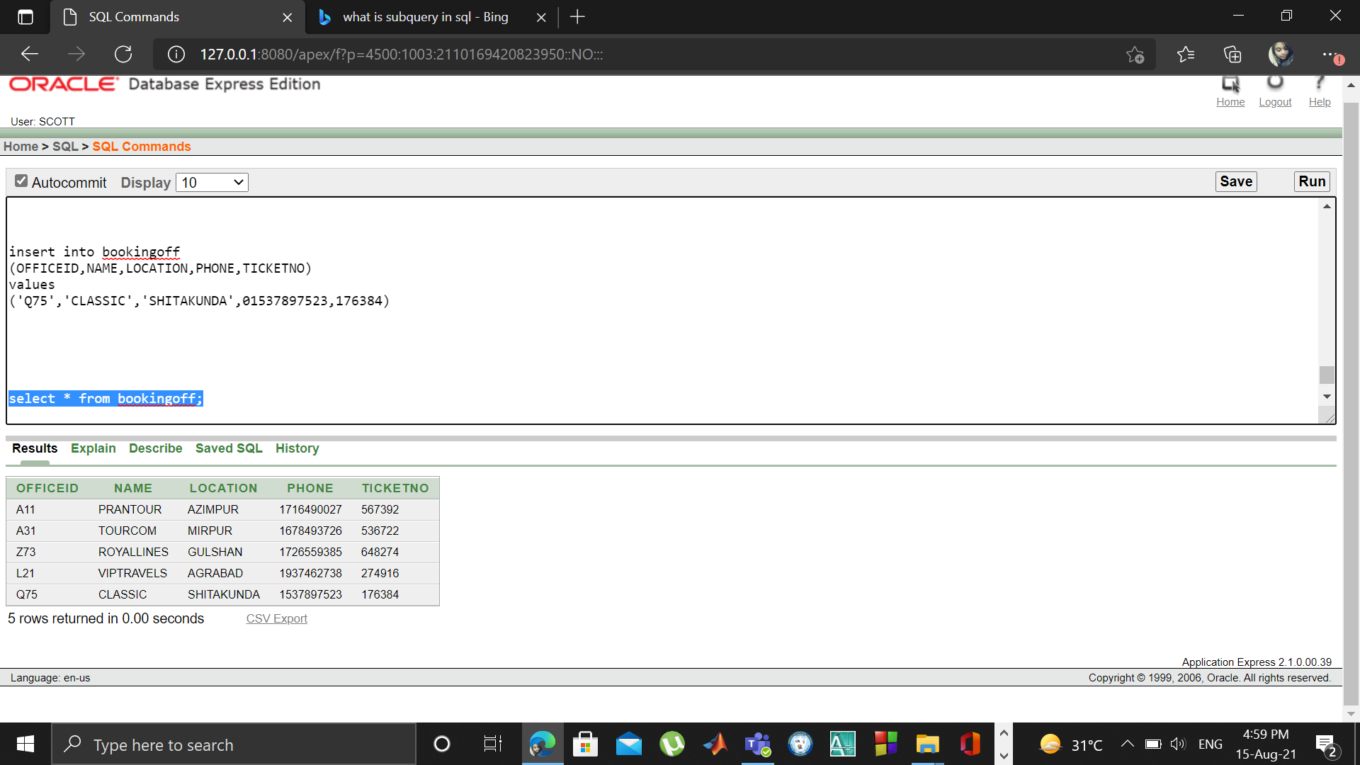

7.Ticket:

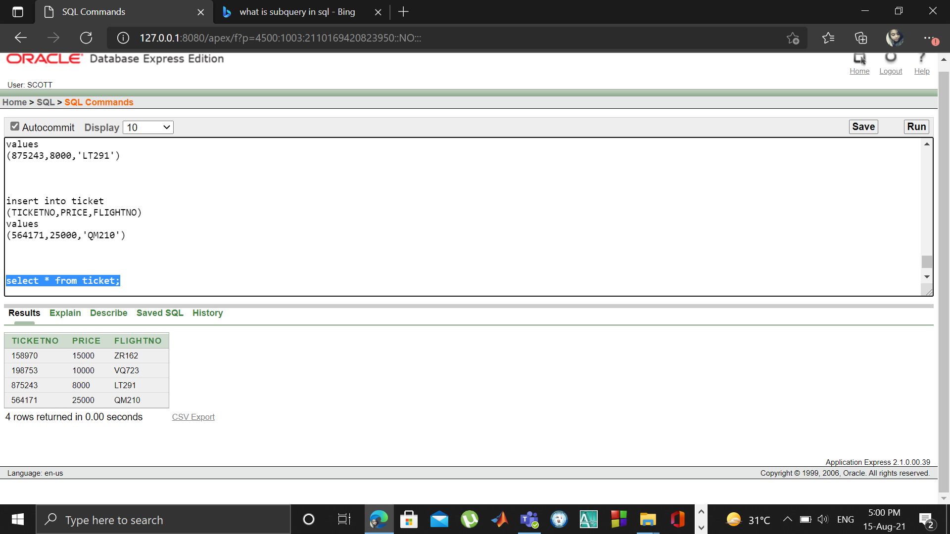

8.Passenger:

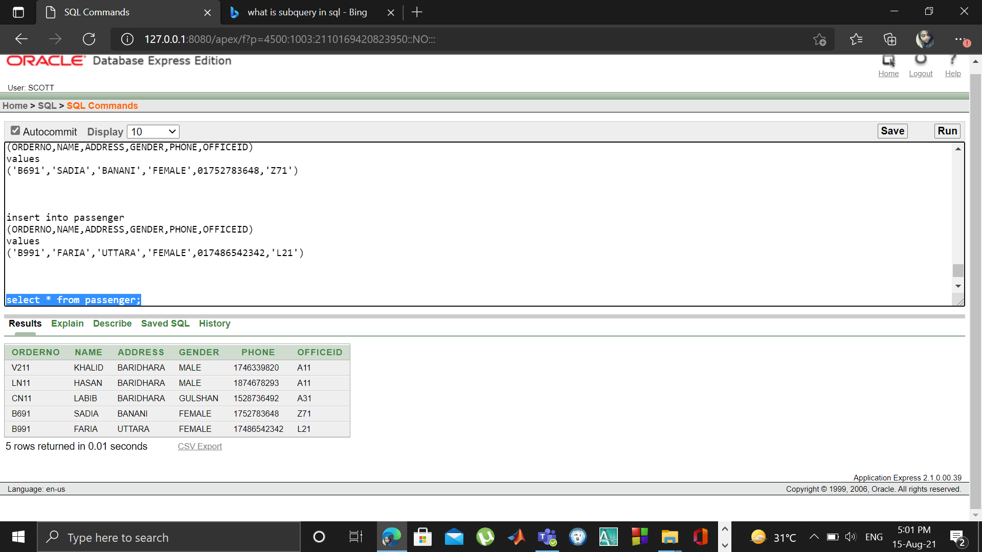

**Joining:**

i.Equi-join:

SELECT w.Name, c.Destination

FROM Airline w , flight c

WHERE w.FlightNo = c.FlightNo;

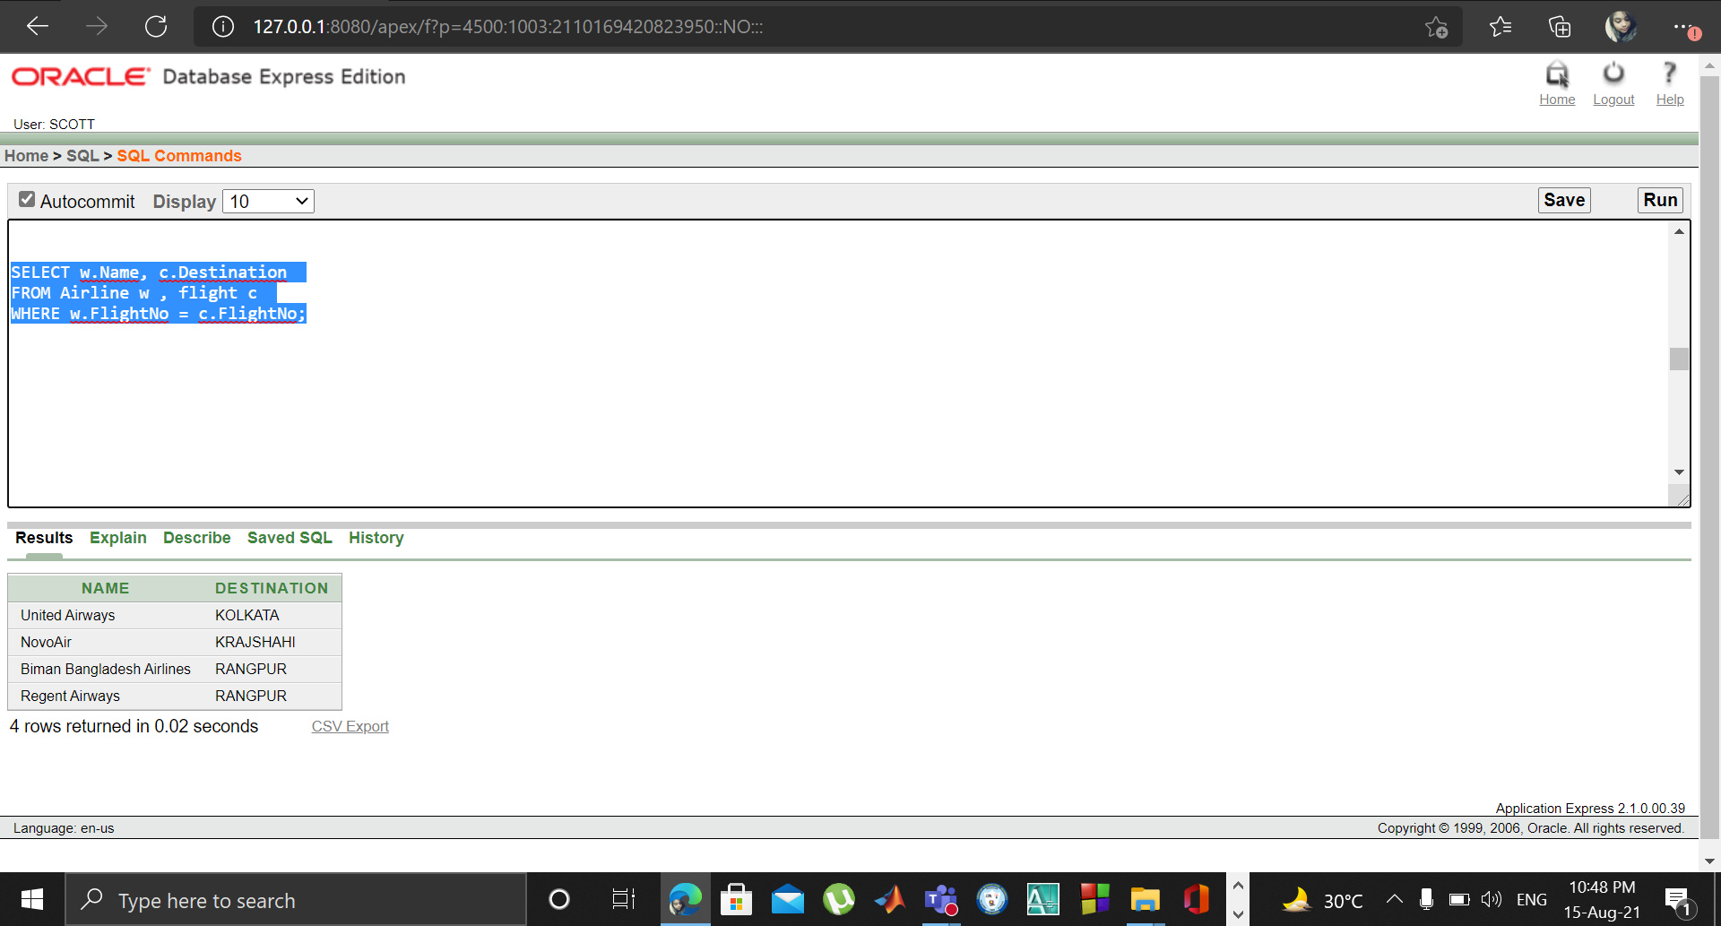

ii.Outer-join:

SELECT w.Name, w.Email, c.Destination

FROM Airline w , flight c

WHERE w.FlightNo(+) = c.FlightNo;

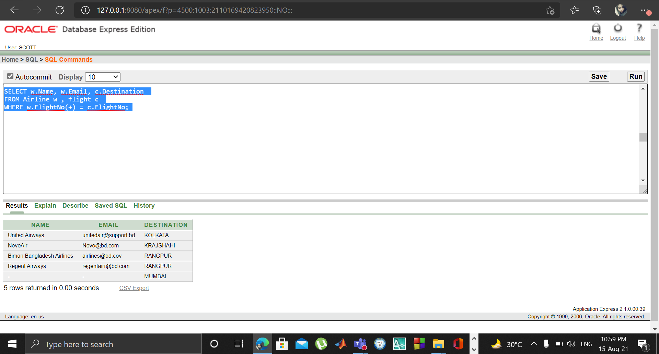

iii.Self-join:

SELECT w.Name||' will be landed in '|| c.Destination

FROM Airline w , flight c

WHERE w.FlightNo = c.FlightNo;

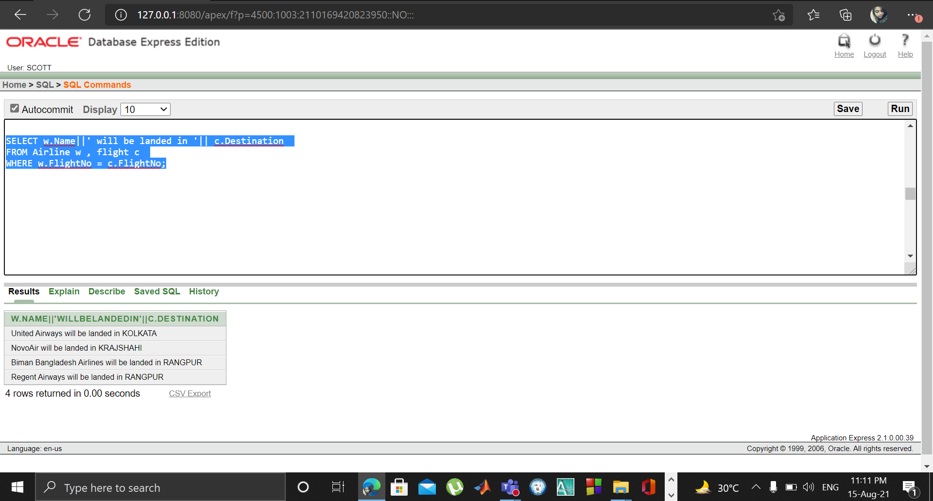

**Sub-query:**

1. Find out the workers name that starts with S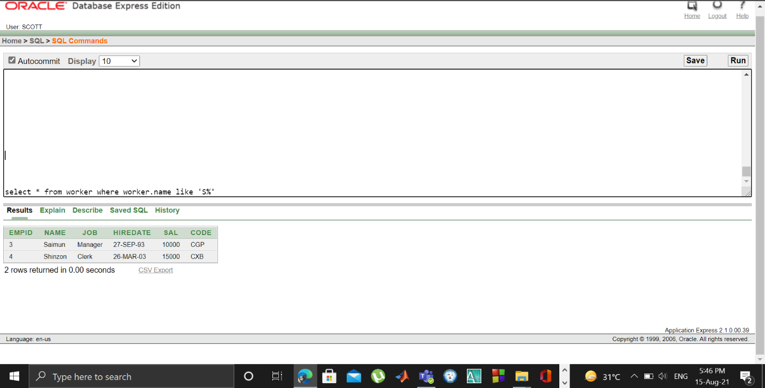

2. Find out airport and airplane details

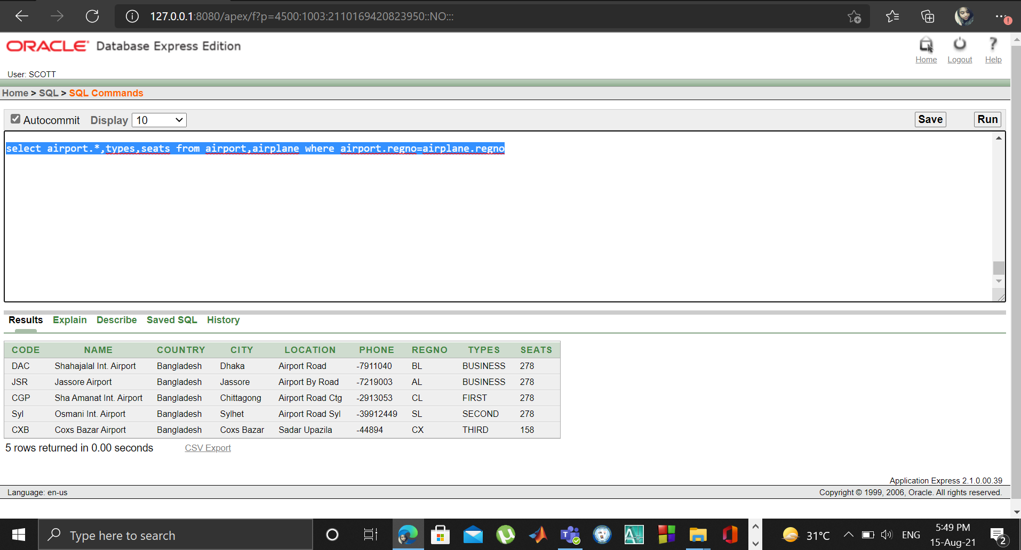

3.Find out passenger name, destination, address, office name, ticket no

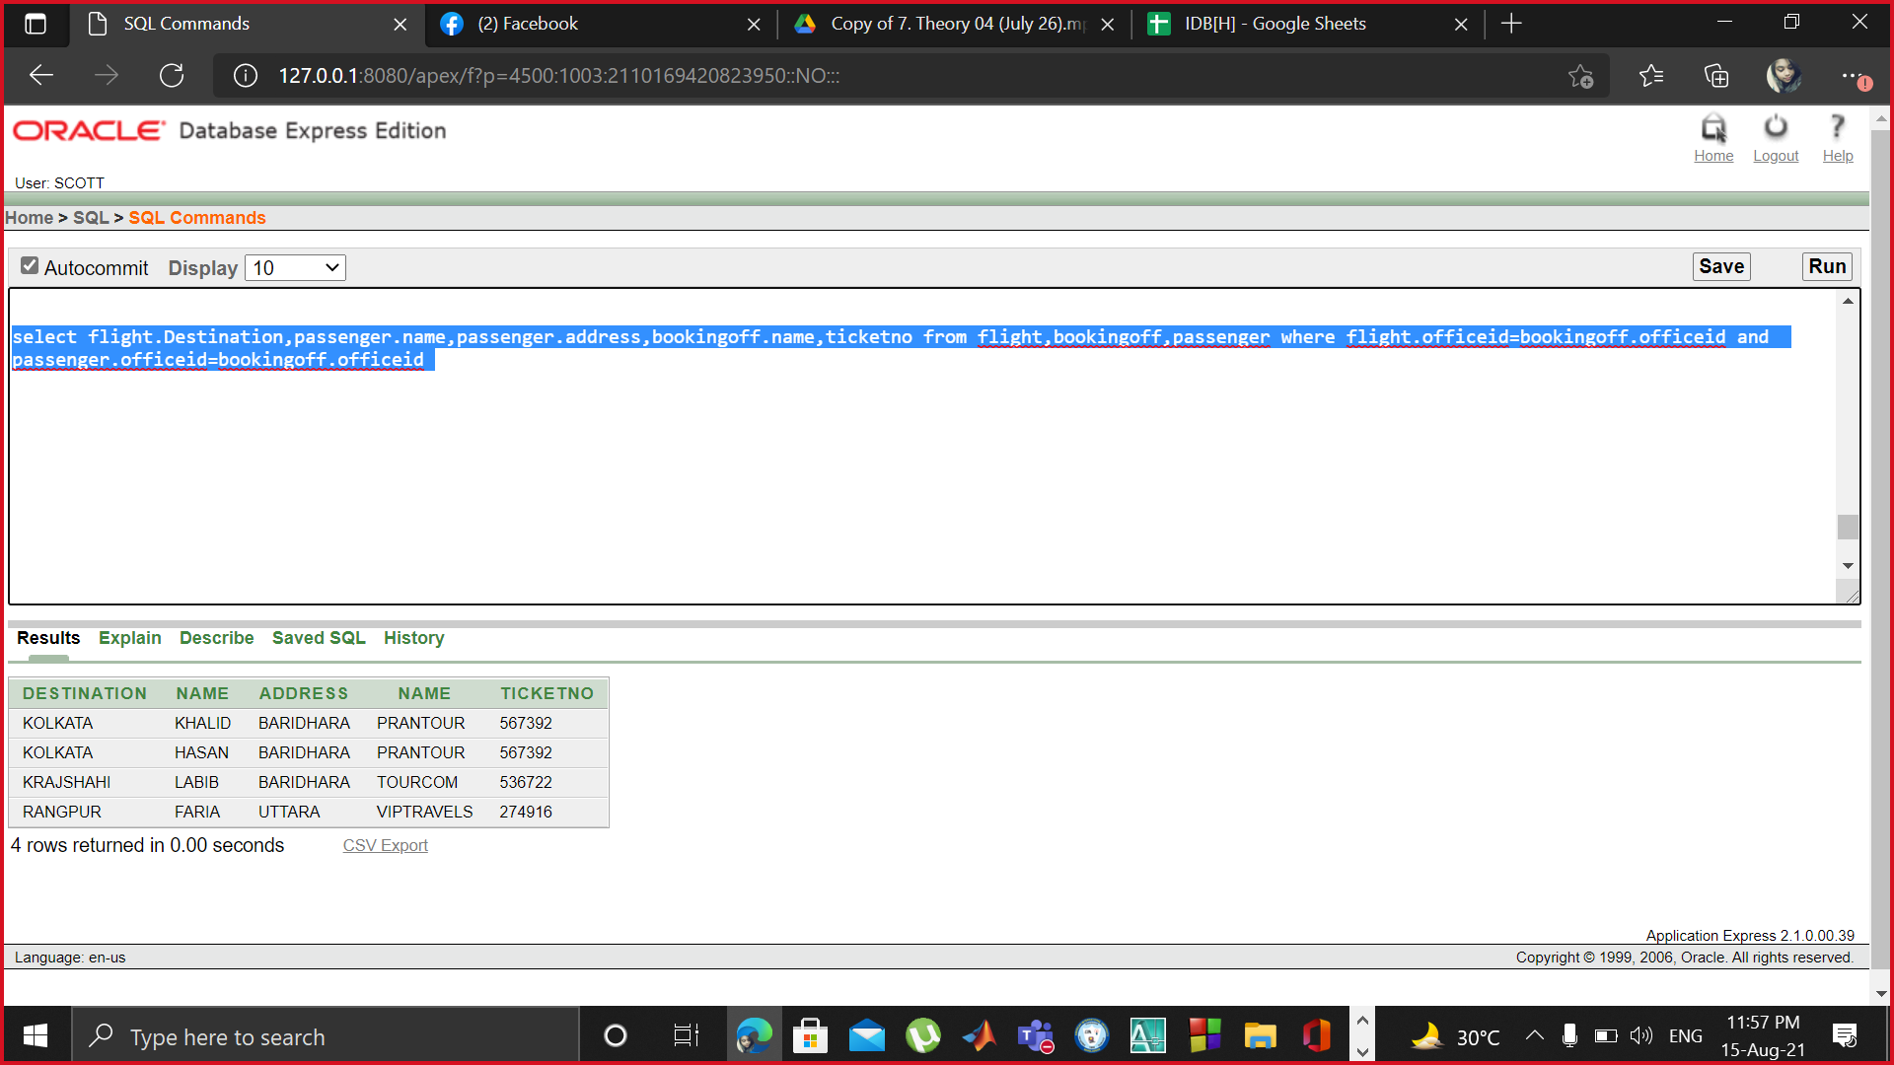

4.Find out the destination that costs more than 10000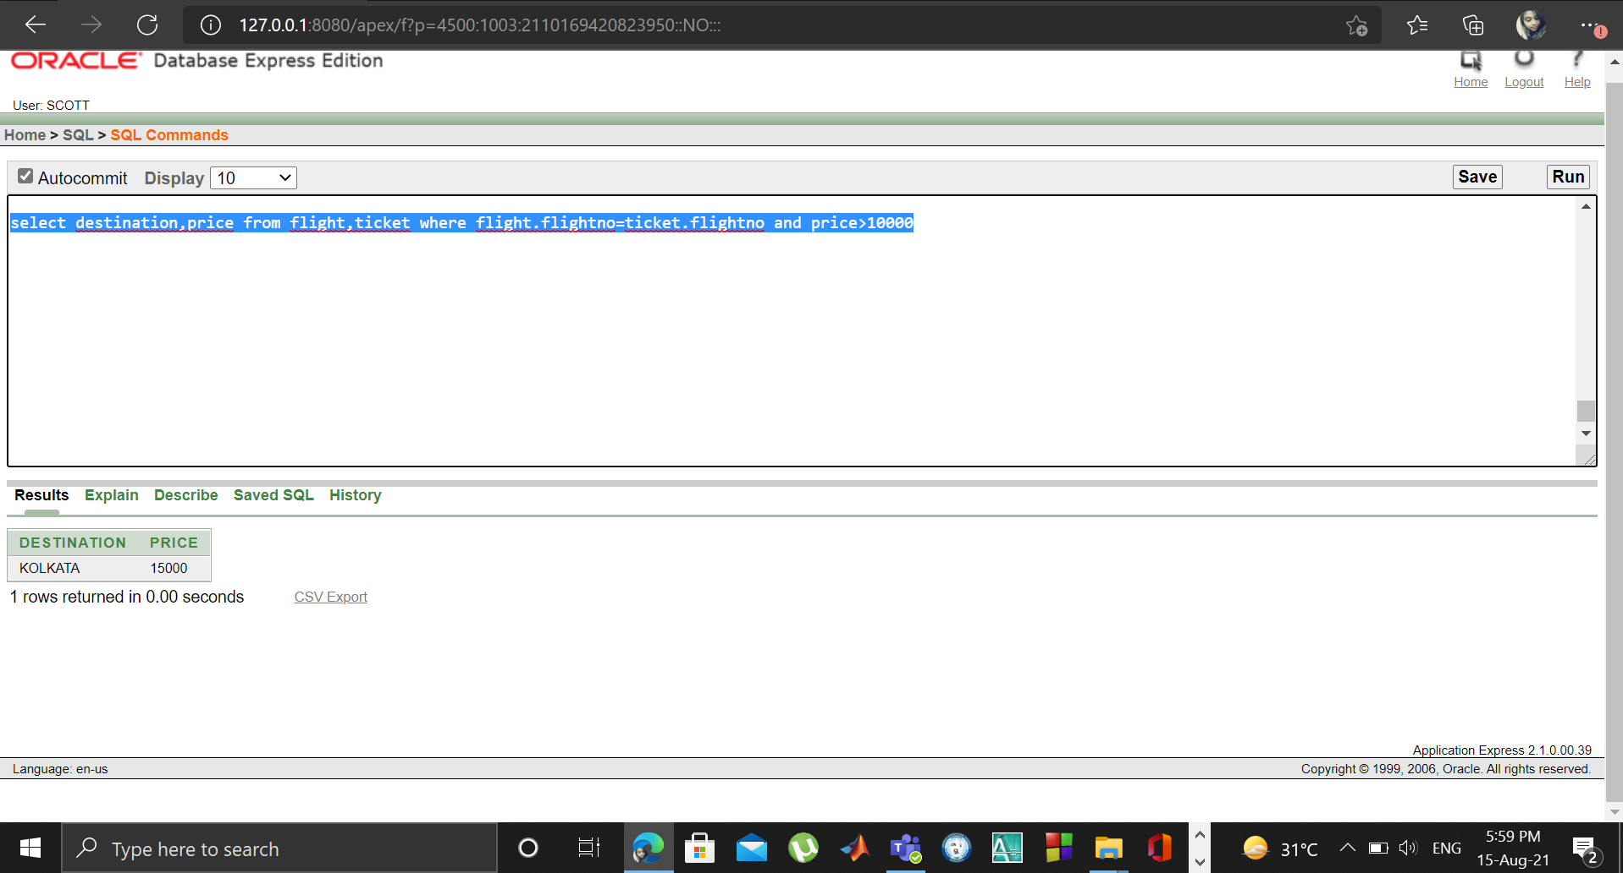

5.Find out the passenger whose name starts with F

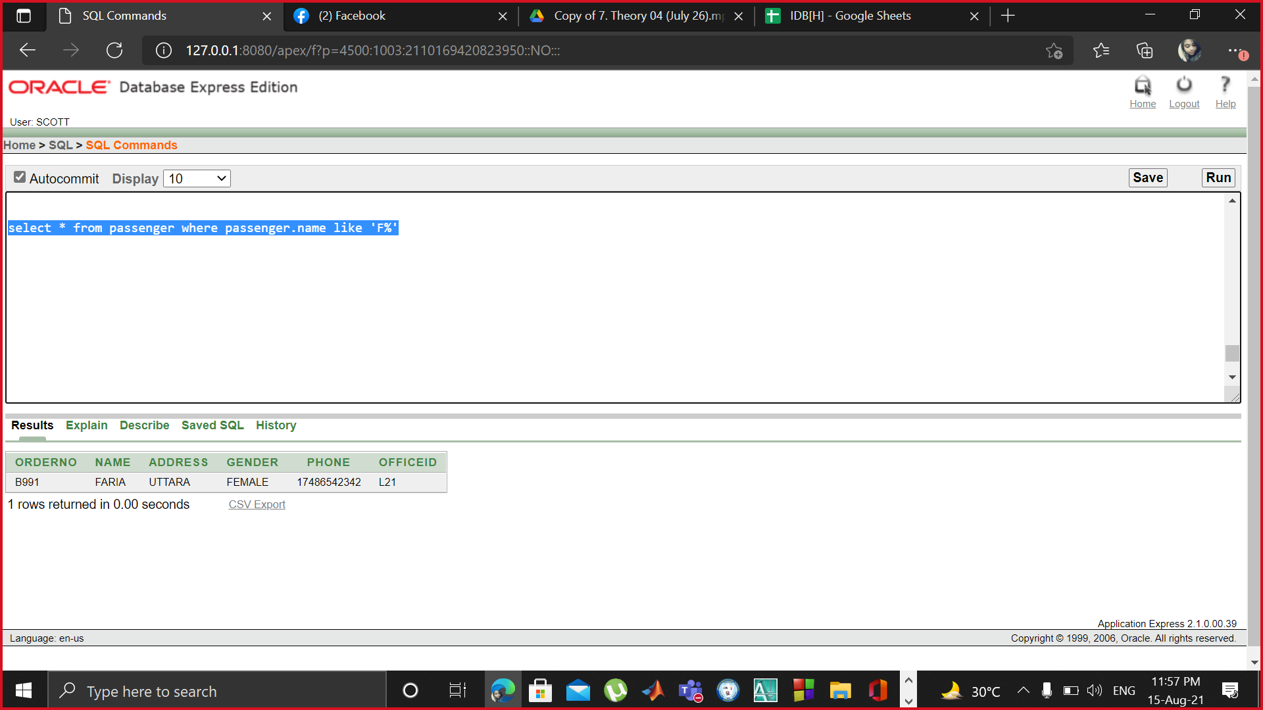

6.find out Officers

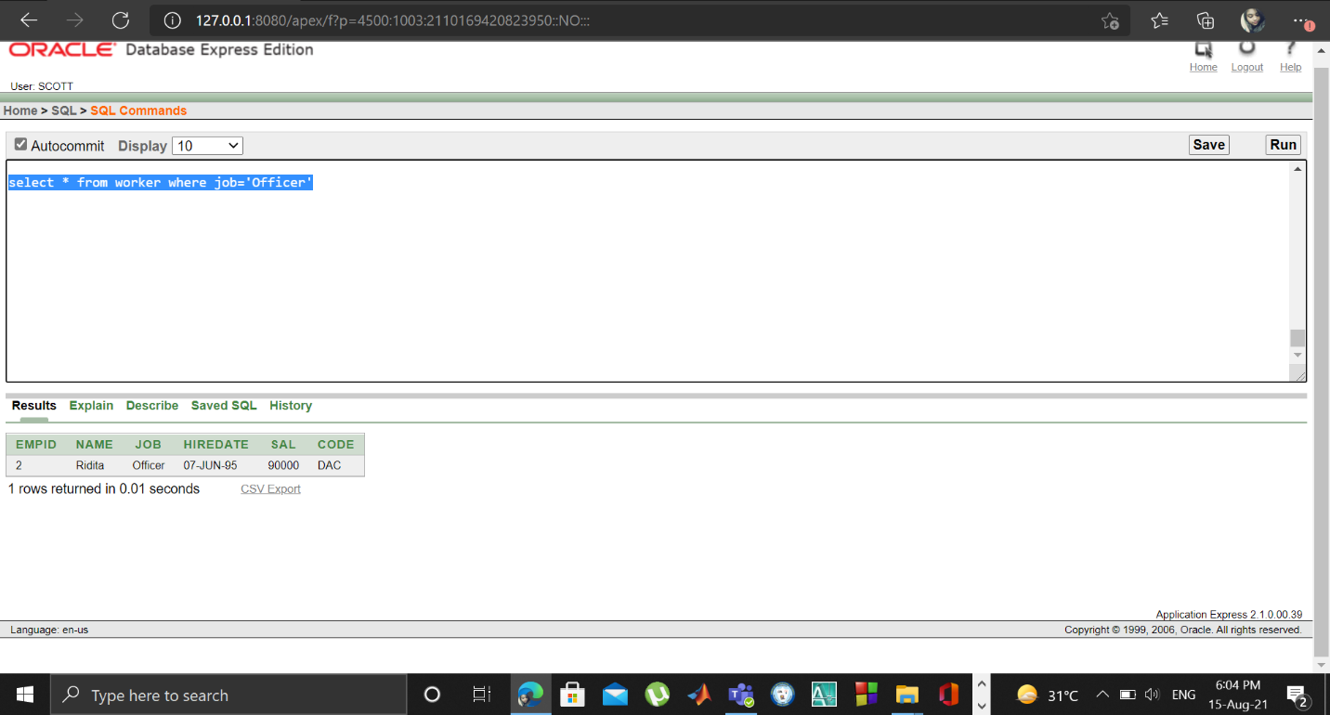

7.find out the names of Clerk and their duty in airport

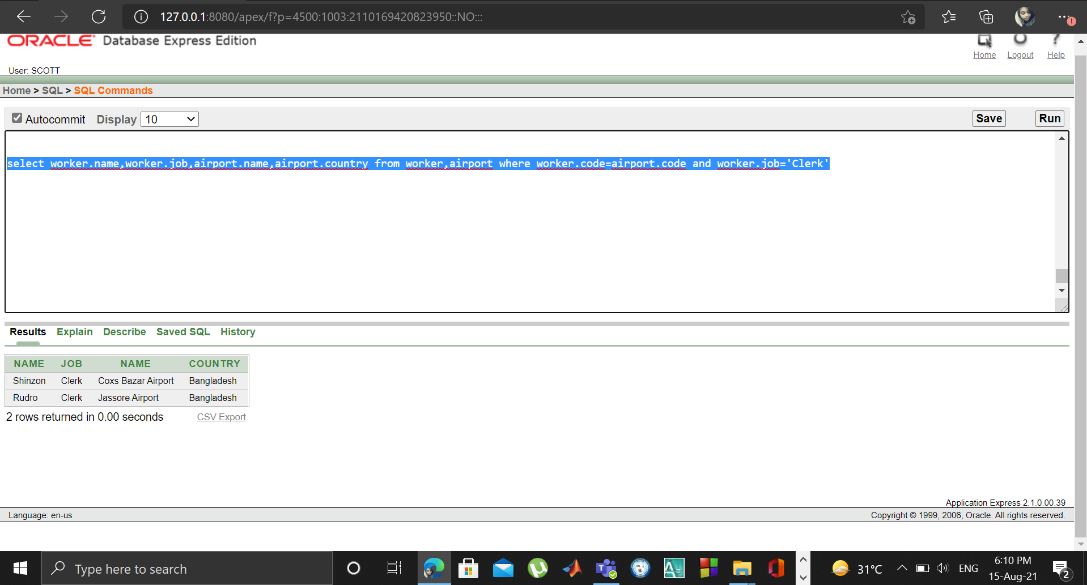

8.Find out the Security whose salary is less than 1000

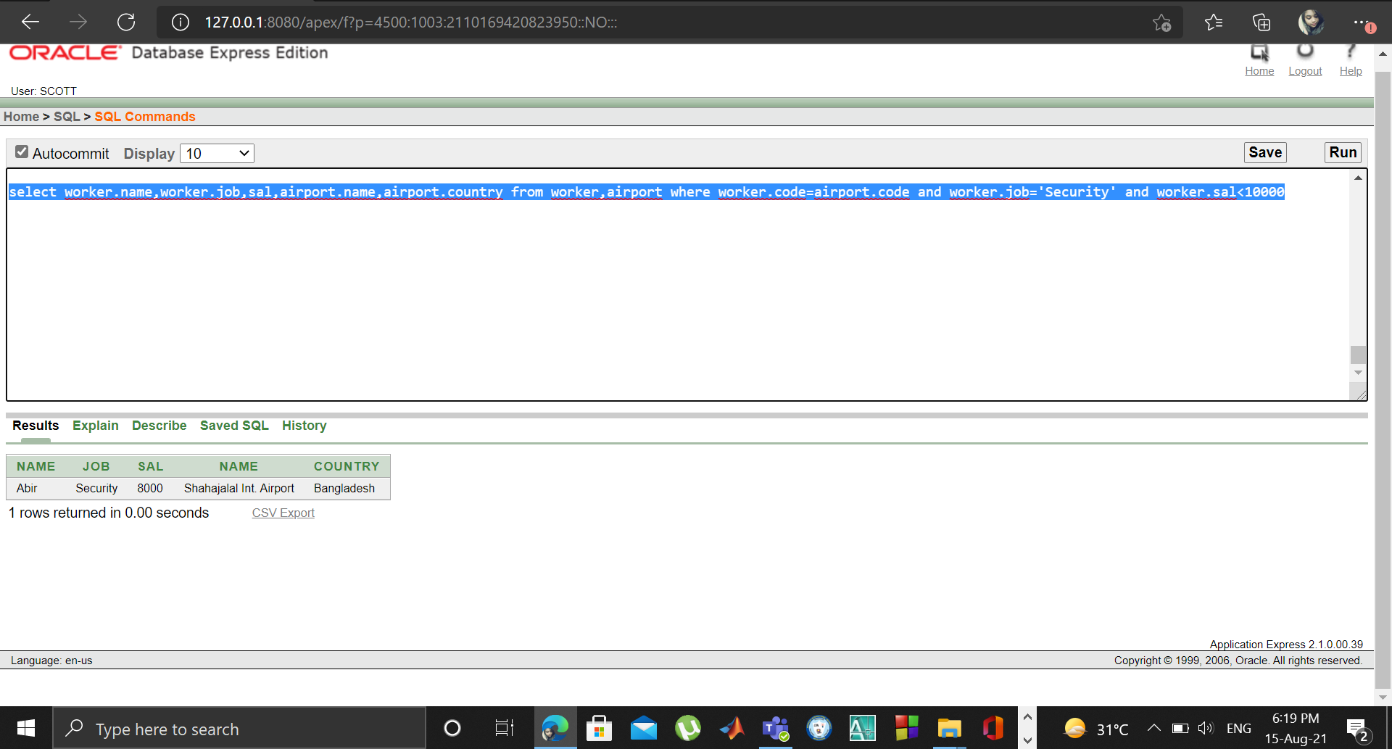

9.Find out passenger name and their booking office address.

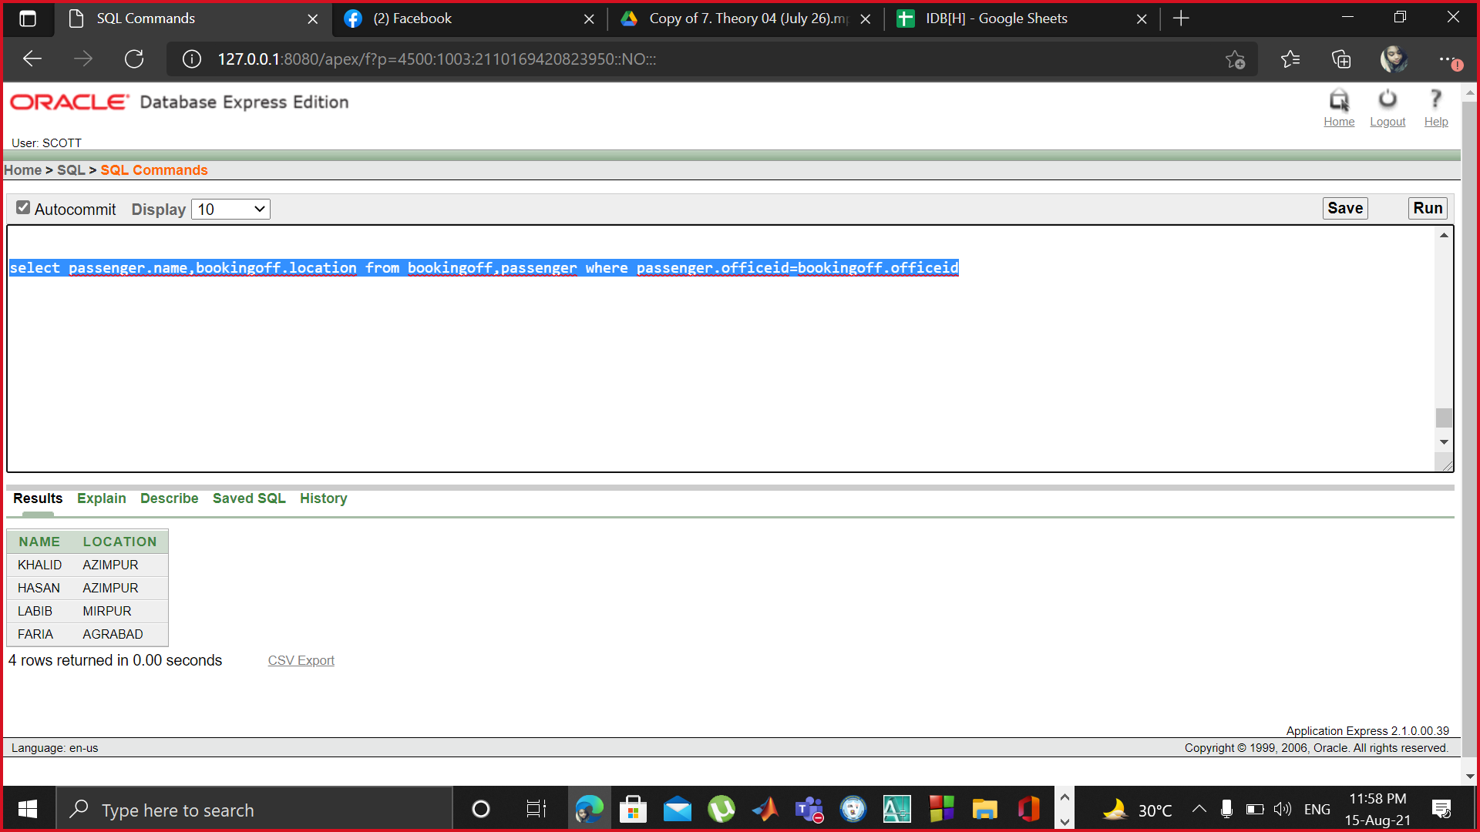

10.Find out airlines and booking office name accordingly

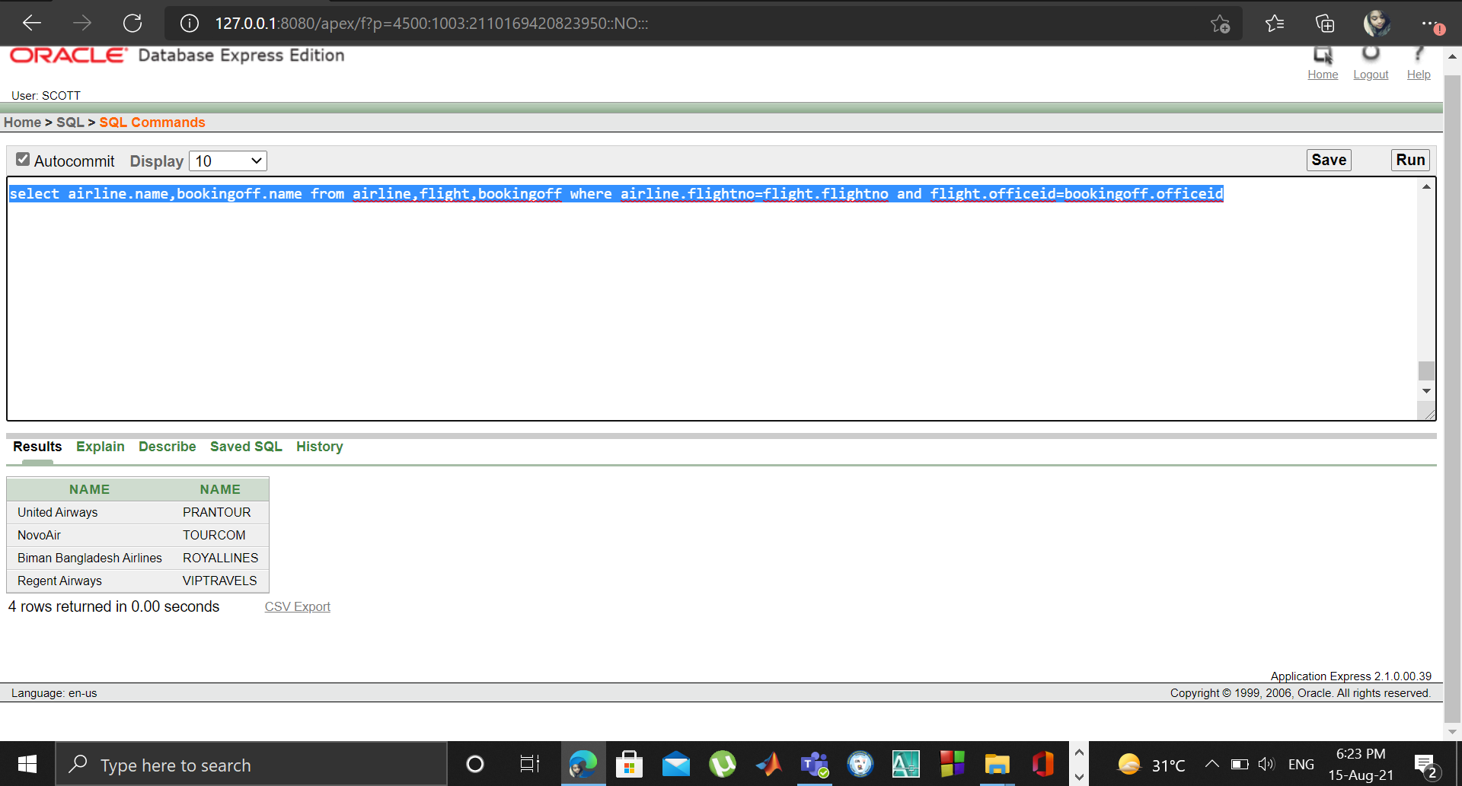

**View:**

Complex View Table Creation:

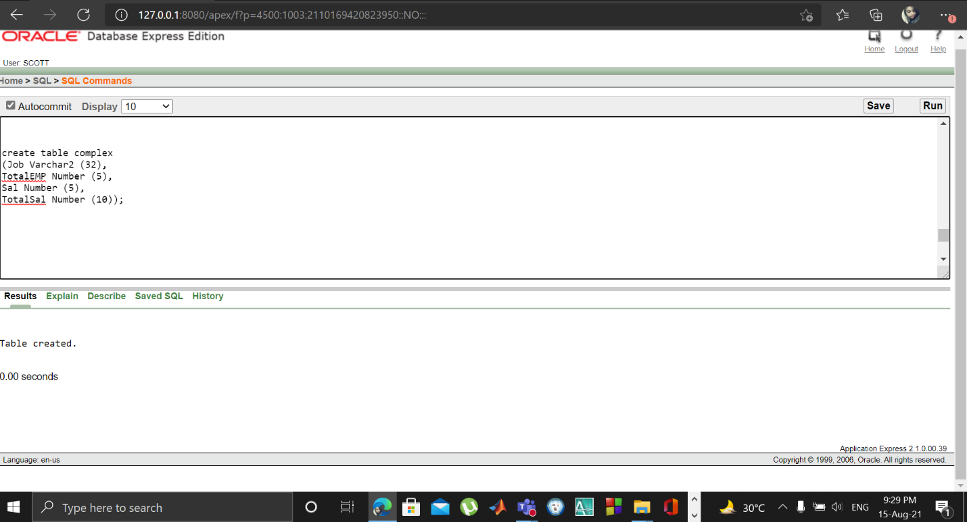

Complex View: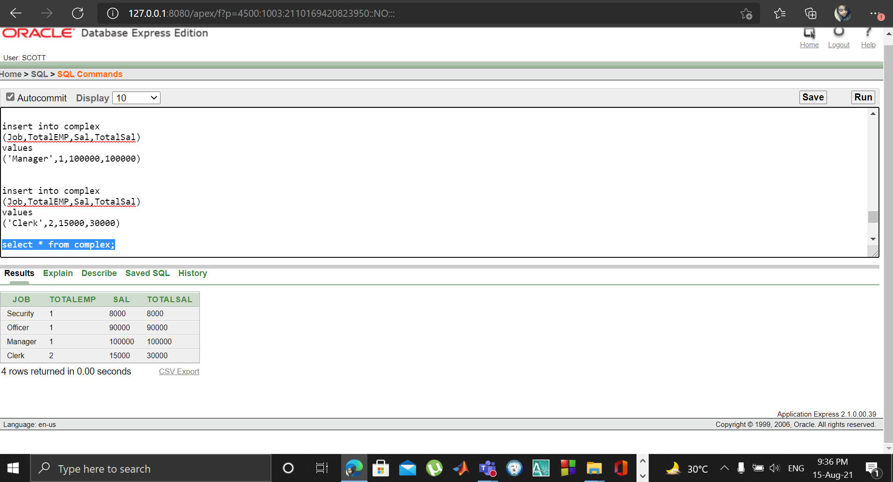

**Constraint in Table:**

